CSE246: Algorithms
Project Report

Sub-Project Code: | P6-C
Sub-Project Title: | Real-Time Dispatch and Cascade Failure Prevention : Push-Relabel and Beyond
Course: | CSE246: Algorithms — Spring 2026
Instructor: | Dr. Tania Sultana, Assistant Professor, East West University
Submission Date: | 19-04-2026

Team Members

# | Full Name | Student ID | Role
1 | Sanzida Rahman | 2024-3-60-236 | Team Lead
2 | Shariful Haque | 2024-3-60-755 | Literature Manager
3 | Zannatul Hasan Roza | 2024-3-60-246 | Analysis Lead
4 | Shashi Roy | 2024-3-60-238 | Writing & AI Lead

Department of Computer Science & Engineering
East West University, Dhaka, Bangladesh

Abstract
This paper presents a systematic literature review of maximum flow algorithms applied to real-time power dispatch and cascade failure prevention in smart grid systems. We surveyed over [30] peer-reviewed papers published between [2013] and [2026], sourced from IEEE Xplore, ACM Digital Library, and Google Scholar. Our review analyzes the theoretical time and space complexity of Ford–Fulkerson, Edmonds–Karp, Dinic’s algorithm, and Push–Relabel, comparing their performance trade-offs in dynamic and large-scale power network environments. The central contribution of this survey is an original comparison table synthesizing complexity characteristics, application relevance, and operational limitations across all studied algorithms. The analysis reveals a clear progression from global augmenting-path approaches to localized flow-based strategies, with Push-Relabel demonstrating superior practical efficiency in real-time scenarios. Additionally , flow-based vulnerability analysis methods are shown to provide more accurate identification of critical transmission corridors compared to purely topological techniques.Our study identifies three significant research gaps: the absence of integrated large-scale real-time implementations using max-flow algorithms, the lack of direct empirical comparison across major algorithms within smart-grid environments, and the limited integration of classical flow models with modern computational and renewable-driven grid dynamics. These findings suggest promising directions for future research in scalable, real-time, and adaptive flow optimization for next-generation power systems.

Keywords: maximum flow algorithms, push–relabel, smart grid optimization, cascade failure prevention, min-cut analysis, real-time power dispatch

1. Introduction
1.1 Motivation and Background
Real-time power management and preventing cascade blackouts represents critical and challenging objectives in advanced power systems, which are becoming increasingly complex due to unpredictable consumption, large scale renewable energy adoption [1], and continual expansion of interconnected networks.Managing these challenges requires constant co-ordination between supply and demand, while sustaining network stability, emphasizing the critical role of real-time operational decisions in achieving reliable and secure grid performance [2]. In complex interdependent networks, a prominent risk is the cascade failures, where a single point of fault sparks future disturbances across interconnected subsystems. This escalating sequence can extend through the network, leading to widespread dysfunction and potential systemic collapse [3]. Past major outages, such as the 2003 Northeastern U.S. blackout and the 2012 Indian power failure demonstrate how systemic failures on a massive scale can have profound and extensive effects on almost every aspect of today’s society [4].
With increasingly complex power systems , there is a pressing need for real-time dispatch models capable of handling dynamic operation conditions. Network flow-based optimization techniques provide a rigorous mathematical framework for encoding transmission constraints … Notably , the push-relabel algorithm , in particular , serves as a core method for tackling the maximum flow problem , owing to its computational effectiveness and broad applicability [5].

1.2 Problem Statement
Smart power grids are systems that distribute electricity all the time.They have to balance how much electricity is made and how much is used away. Electricity flows through transmission lines that can only handle so much. Even small problems can affect the network and make it unstable. This makes controlling power in time very hard. We need reliable ways to make decisions to keep the system stable and efficient [6].
In this survey we look at how electricity moves through a power grid. We focus on a problem called the maximum flow problem. We want to compare four algorithms that help solve this problem: Ford-Fulkerson, Edmonds-Karp, Dinic’s algorithm and Push-Relabel algorithm. These algorithms help optimize flow. They work differently.
- Ford-Fulkerson and Edmonds-Karp are slower because they search for paths over the network.
- Dinic’s algorithm works better because it uses graphs called level graphs.
- Push-Relabel is often faster in networks because it uses local operations[7].
A cascading failure in a power grid happens when one part of the grid fails. This failure spreads to other nearby lines. The power grid is made up of lines that work together. When one line in the power grid is overloaded it puts load on other lines in the power grid. These other lines in the power grid may also fail one after another. This is like a chain reaction. The chain reaction can finally lead to a blackout that affects many areas in the power grid.This makes the stability of the power grid sensitive and difficult to control in real time[8]. Researchers use methods like Max-Flow Min-Cut to study the power grid. They want to know which parts of the power grid are most important. These methods help identify lines in the power grid and weak points in the power grid. If these critical lines in the power grid fail the whole power grid system can become unstable. So researchers use something called vulnerability analysis to improve the safety of the power grid and prevent failures in the power grid[9].
1.3 Research Questions
RQ1. How does the Push-Relabel algorithm's local height-labelling strategy achieve better practical runtime than globally augmenting methods, and what is the formal basis for its O(V²√E) theoretical complexity bound?
RQ2. What algorithmic approaches for cascade failure detection and prevention in smart power grids have been documented in peer-reviewed literature — specifically, how do flow-based methods identify critical transmission corridors before failure occurs?
RQ3. What are the most significant research gaps in applying max-flow algorithms to national-scale smart grid real-time dispatch — particularly regarding computational latency requirements, grid size scalability, and integration with renewable energy variability?
1.4 Paper Organisation
The remainder of this paper is organised as follows. Section 2 provides the theoretical background on maximum flow algorithms, including their fundamental concepts, working principles, and computational characteristics. Section 3 describes the methodology used to conduct this systematic literature review, including the search strategy and selection criteria. Section 4 presents the review findings and analysis, where the algorithms are examined comparatively and their applications in power systems are discussed. Section 5 discusses the identified research gaps and provides answers to the research questions based on the findings. Finally, Section 6 concludes the paper by summarizing the key insights and outlining directions for future research.
2. Background
2.1 Algorithmic Paradigm Overview
Network flow algorithms are a group of graph-based methods used to send a resource through a network in the best possible way. A flow network is a directed graph G=(V,E) where each edge (u,v) has a capacity c(u,v)>=0. It has nodes (vertices), directed edges,edge capacities, and two special nodes: a source s and a sink t. The goal of the maximum flow problem is to send the maximum amount of flow from s to t without exceeding any edge capacity.
A very important idea is the residual network, which shows how much more flow can still be sent after some flow is already assigned. It also allows previous flow to be corrected or reduced using reverse edges, helping improve the solution step by step[10].
Augmenting Path Algorithms (Global Approach)
Traditional approaches such as Ford-Fulkerson algorithm, Edmonds-Karp, and Dinic’s algorithm follow a strategy of searching for an augmenting path from the source to the sink node and pushing flow through it.
Ford-Fulkerson selects any path
Edmonds-Karp selects shortest paths using BFS
Dinic’s algorithm employs layered graphs
These strategies have been referred to as global strategies since they require scanning the entire network to find an appropriate augmenting path at each iteration. Cruz-Mejia and Letchford note that the global search approach is inefficient for large or dynamic networks[10].
Push-Relabel Algorithm (Local Strategy)
There is an alternative method known as the Push-Relabel algorithm. In place of finding full paths, it uses local actions at the vertices. The preflow-push method allows for excess flow at vertices and then solves it progressively.
Push: Send excess flow to a neighboring vertex
Relabel: Increase the height of the vertex if push cannot occur
Such an approach prevents scanning of the entire network; thus it operates quickly in massive-scale networks such as power grids. According to Orlin, advanced flow techniques can equally result in very efficient results in sparse networks[11].
Paradigm Shift & Smart Grid Applications
Overall, network flow algorithms evolve from global search based methods to local update-based methods,improving scalability and real-time performance. This shift is especially important in smart grid systems, where fast response is required for real-time dispatch and cascade failure prevention[11][12].
2.2 Core Algorithm Definitions
Understanding the progression toward efficient real-time flow computation requires analyzing the evolution of maximum-flow algorithms. These algorithms have evolved from straightforward augmenting-path techniques to advanced approaches based on local optimization,leading to improved efficiency and scalability .This section reviews four foundational algorithms—Ford-Fulkerson, Edmonds-karp, Dinic’s, and Push-Relablel—emphasizing their working principles,complexities,and contributions to this evolution.
Ford-Fulkerson Algorithm
The Ford-Fulkerson algorithm solves the maximum-flow problem by repeatedly increasing flow from a source (s) to sink (t) using augmenting paths. It begins with zero flow and searches for a path in the residual network where additional flow can still be sent .For each such path, the smallest remaining capacity along that path (the bottleneck) determines how much flow can be added. The flow is updated accordingly,and the residual network is adjusted, including reverse edges that allow previously assigned flow to be reduced or redirected if needed.The iterative augmentation process of Ford–Fulkerson is illustrated in Fig. 1.

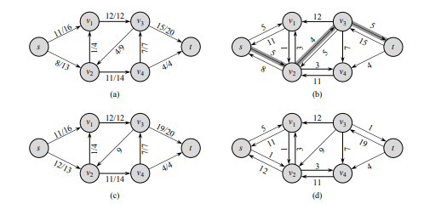
Fig. 1. Step-by-step execution of the Ford–Fulkerson algorithm: (a) initial flow network, (b)–(d) successive augmenting path selections and corresponding flow updates in the residual network. Adapted from Introduction to Algorithms (CLRS), Ch. 26.
This process continues until no augmenting path exists, at which point the maximum flow is reached .The core computational step of the algorithm is the repeated search for an augmenting path in the residual graph and updating the flow along that path.[13]
The running time depends on how augmenting paths are chosen . In the general case,the time complexity is (O(E.|F*)) , where (E) is the number of edges and ( |f*| ) is the value of the maximum flow . This occurs because each iteration increases the total flow by at least one unit when capacities are integers,so there can be at most (|f*) iterations. In each iteration,the algorithm must find an augmenting path,which requires traversing the graph and takes (O(E)) time. Multiplying these gives the overall time complexity. If augmenting paths are chosen poorly, the algorithm may run very slowly, and for non-integer capacities it may not even terminate. On the other hand,the space complexity is (O(V+E)),where (V) is the number of vertices.This is because the algorithm stores the graph structure and its residual network,along with flow and capacity values for each edge[13].
Edmonds-Karp Algorithm
The Edmonds-Karp algorithm is a refinement of the Ford-Fulkerson method for computing the maximum flow in a directed network G=(V,E) with source s and sink t. Its input is a capacitated flow network, and its output is the maximum flow from sss to t. The key distinction is that it always selects augmenting paths using breadth-first-search(BFS), ensuring that the shortest path in terms of number of edges is chosen[13][14].
The fundamental computation consists of repeatedly applying BFS on the residual graph to locate the shortest augmenting path, followed by updating the flow along that path using the minimum residual capacity.

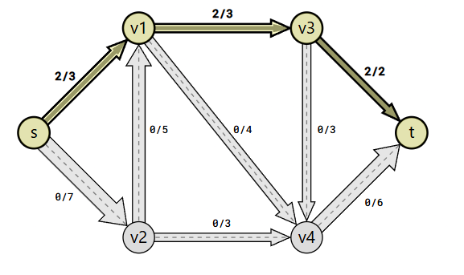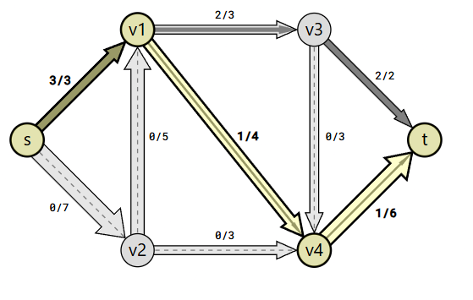
(a) (b)
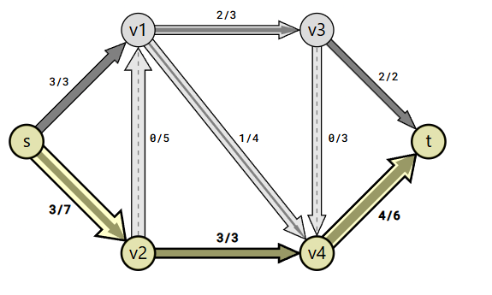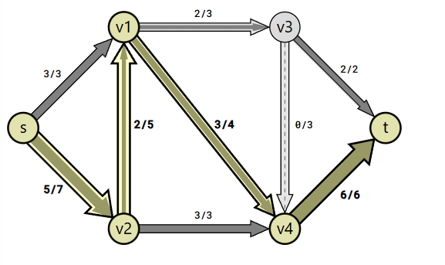

Fig. 2. Execution of the Edmonds–Karp algorithm using BFS-based shortest augmenting paths: (a)–(d) successive iterations showing flow augmentation and residual graph updates. Adapted from GeeksforGeeks.
This disciplined mechanism guarantees that vertex distances from the source remain non-decreasing over time, which limits poor path choices and results in more stable performance than unrestricted selection methods[13].
The time complexity is O(VE²), where V denotes the number of vertices and E the number of edges. This arises because each BFS traversal requires O(E) time, and the number of augmentations is bounded by O(VE), as the shortest path distances increase over time. The space complexity is O(V+E), since the algorithm maintains the graph, residual network, and BFS structures. Although this ensured polynomial-time execution, the repeated global traversals reduce efficiency for large or dynamic networks[13].

Dinic’s Algorithm
Dinic’s algorithm is a maximum flow method that improves older techniques like Ford–Fulkerson by sending flow in a more organized and efficient way. Instead of randomly searching for augmenting paths, it uses a layered structure of the graph, which makes the process faster and more systematic [10].
In the following input graph,
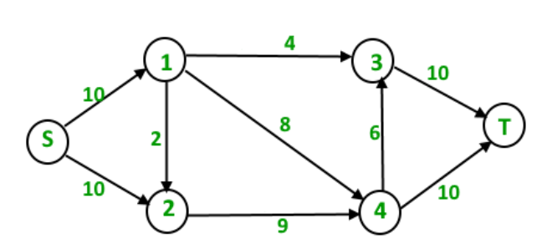
The maximum s-t flow is 19 which is shown below
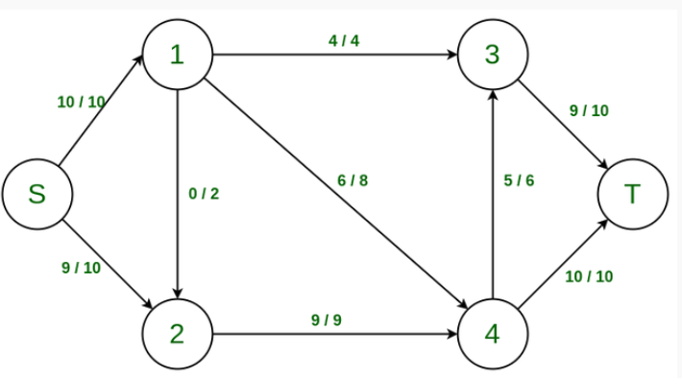
Source: GeeksforGeeks (n.d.), Dinic’s Algorithm – Maximum Flow
This diagram shows how the graph is divided into different levels (layers) based on the shortest distance from the source node. Only edges that go from one level to the next are kept. Flow is then pushed through this layered structure until no more paths from source to sink exist. After that, the level graph is rebuilt and the process continues again.
The main idea of Dinic’s algorithm is to construct a level graph, where each node is assigned a level based on its shortest distance from the source in the residual graph. Then a blocking flow is computed, meaning flow is pushed until no more augmenting path exists in that level graph. After completing one phase, the level graph is rebuilt, and the process continues until no more flow can be sent [15].
In practice, this level-based approach avoids unnecessary or long path searches, making Dinic’s algorithm much faster than basic Ford–Fulkerson. It is especially efficient in unit capacity graphs and layered networks. Because of this, it is widely used in competitive programming and real-world network flow problems due to its speed and predictable performance [15].
From a theoretical point of view, Dinic’s algorithm has a time complexity of O(V²E) in general graphs. In unit capacity graphs, it becomes faster, reaching O(E√V), because the number of level graph phases is limited. This structured improvement has influenced many modern maximum flow algorithms, including Push–Relabel and other advanced optimization-based methods . In terms of space complexity, Dinic’s algorithm uses O(V+E) memory because it stores the residual graph, level array, and adjacency list[16]
Push–Relabel algorithm
The Push–Relabel algorithm is a graph-based method used to solve the maximum flow problem, where the goal is to send the maximum possible flow from a source node s to a sink node t in a directed network with capacity limits. Unlike augmenting-path algorithms such as Ford–Fulkerson, it does not search for full paths from source to sink. Instead, it uses a preflow approach, where flow conservation can be temporarily violated at intermediate nodes [17].
In this method, each node stores two values: excess flow e(v) and height label h(v). The algorithm works using two simple local operations:
- Push: send flow through a valid edge
- Relabel: increase the height of a node when no valid push is possible
An edge (u,v) is called admissible if it has remaining capacity and satisfies h(u)=h(v)+1. This allows the algorithm to work locally on neighboring nodes instead of searching for full paths in the graph [17].
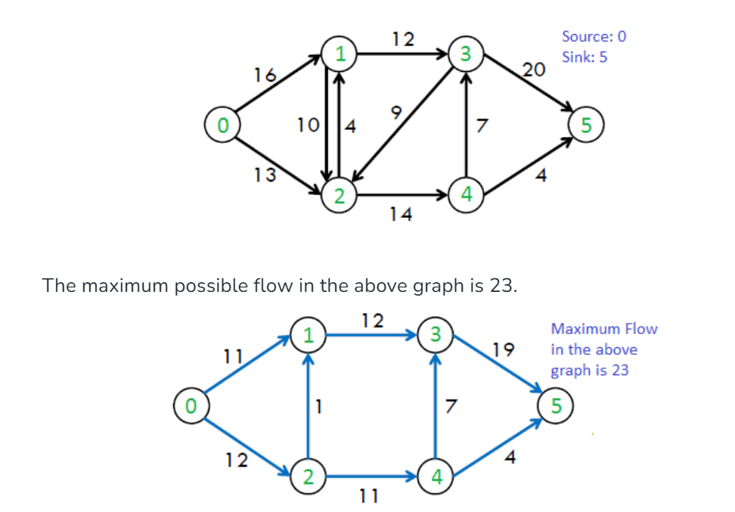
Source: GeeksforGeeks (n.d.), Introduction to Push–Relabel Algorithm
This diagram shows the basic working of the Push–Relabel algorithm. At the beginning, a preflow is created from the source node, which may cause some nodes to have excess flow. The algorithm then applies push operations to send flow through admissible edges. When no valid push is possible, relabel operations are used to increase node heights so that new paths become available. This process continues until all excess flow is pushed toward the sink node and maximum flow is achieved.
The Push–Relabel algorithm starts by sending flow from the source node to its neighboring nodes. This creates excess flow at those nodes. After that, the algorithm repeatedly chooses an active node (a node with excess flow e(v)>0, where( v≠s,t) and tries to move the flow forward.
If possible, it performs a push operation, sending flow along an admissible edge using
δ=min(e(u),cf​(u,v)), which means it sends the minimum of available excess flow and remaining capacity. If no valid edge is available, it performs a relabel operation, increasing the node’s height as
h(u)=1+min⁡{h(v)} over its neighbors. This process continues until no active nodes remain [17].
In practice, the algorithm is improved using gap relabeling, global relabeling, and highest-label selection, which make it faster in real networks [17]. The worst-case time complexity is O(V²E).However, improved versions, such as the highest-label variant, achieve a better bound of O(V²√E) . This improvement comes from a more careful analysis of how flow is pushed in the network. Instead of considering all operations equally, the algorithm groups them into phases and balances the work done in each phase using a parameter K=√E. This reduces the total number of inefficient operations and leads to an overall time complexity of O(n²√m) where n=∣V∣and m=∣E∣ [18]. . The space complexity is O(V+E), because it stores the graph, height values, and excess flow information[16].
2.3 Application Domain Primer
The application domain of this study is the electric power transmission grid, which can be modeled as a graph where nodes represent substations (buses) and edges represent transmission lines. This abstraction allows complex electrical systems to be analyzed using network flow algorithms, while still reflecting real-world constraints such as capacity limits and load distribution. In practice, power flow is governed by physical laws, but graph-based models are widely used to approximate system behavior for optimization and vulnerability analysis [19][20].
A key operational problem in this domain is real-time power dispatch, which involves continuously adjusting electricity flow to match changing demand and supply conditions. With the integration of renewable energy sources, modern grids face high variability, requiring fast and scalable computational methods. Recent studies show that real-time dispatch systems increasingly rely on graph-based optimization and fast flow recomputation techniques to handle dynamic network conditions efficiently [19][21].
Another critical aspect is cascading failure prevention. A cascading failure occurs when the outage of one transmission component causes overloads in neighboring components, triggering a chain reaction that can lead to large-scale blackouts. Unlike purely topological analysis, modern research emphasizes flow-based approaches, where the redistribution of power is explicitly modeled to identify vulnerable transmission lines and critical corridors [20][22].
These challenges make the power grid an ideal domain for maximum-flow algorithms. Such algorithms help identify bottlenecks, evaluate transfer capacity, and detect critical network cuts. While they do not fully replace physical power-flow models, they provide a computationally efficient foundation for analyzing large-scale and dynamic systems. This directly motivates the analysis in Section 4, where these algorithms are evaluated based on their effectiveness in real-time dispatch and cascade failure scenarios.
3. Methodology
3.1 Search Strategy
To make this literature review systematic, traceable, and directly aligned with the goals of this project, a structured search strategy was followed. The search focused on identifying peer-reviewed research that connects maximum-flow algorithms with real-time smart grid dispatch, network vulnerability, and cascade failure prevention.
Databases searched:
- IEEE Xplore (ieeexplore.ieee.org)
- ACM Digital Library (dl.acm.org)
- Google Scholar (scholar.google.com)
- ResearchGate (researchgate.net)
- Semantic Scholar (semanticscholar.org)
These databases were selected because they index the majority of high-quality publications in graph algorithms, network flow theory, optimization, and power system applications, which are central to this study.
search strings used:
Search string 1: "maximum flow" AND "push relabel" AND "real-time dispatch"
Search string 2: "Dinic algorithm" AND "smart grid" AND "network flow"
Search string 3: "max flow min cut" AND "cascade failure" AND "power grid"
Search string 4: "Ford Fulkerson" AND "transmission network" AND "flow"
Search string 5: "network flow" AND "vulnerability analysis" AND "smart grid"

3.2 Inclusion and Exclusion Criteria
Inclusion Criteria | Exclusion Criteria
- Published in peer-reviewed venues indexed by  IEEE Xplore,  ACM Digital Library, or other reputable publishers such as Springer and Elsevier.  - Published between 2013 and 2026, with foundational classical works included when necessary for algorithm definitions.  - Discussed at least one of the core algorithms: Ford–Fulkerson, Edmonds–Karp, Dinic, or Push-Relabel.  - Included formal algorithm descriptions, complexity analysis, or performance evaluation.  - Connected algorithmic concepts to applications such as smart grids, power transmission networks, cascade failure, or network vulnerability analysis.  - Written in English and available in full-text form for detailed analysis. | - Non-peer-reviewed sources such as blogs, Wikipedia pages, Medium articles, and lecture notes.  - Studies that discuss power systems but do not include any algorithmic or graph-theoretic approach.  - Papers that mention maximum flow only superficially without explaining algorithms or complexity.  - Duplicate studies retrieved from multiple databases.  - Papers without accessible full text.  - Studies published before 2010 that are not considered foundational or widely cited in algorithm literature.

3.3 Paper Selection Summary
[ Fill in the numbers from your actual search. These numbers tell the reader how rigorous your search was. ]
Total papers found in initial search | 59
Papers removed after title/abstract screening | 19
Papers removed after full-text review | 10
Final papers included in this review | 30

4. Review and Analysis
4.1 Push-Relabel Algorithm in Real-Time Flow Systems
The push-relabel algorithm has been widely recognized in recent literature as one of the most effective approaches for solving maximum flow problems in large-scale and dynamically changing networks. Its advantage stems from a fundamentally different strategy compared to augmenting-path methods. Instead of repeatedly searching for complete source-to-sink paths, the algorithm operates locally by maintaining a preflow and redistributing excess flow between neighboring nodes using a height-labeling mechanism. This localized approach eliminates the need for repeated global traversals, which significantly reduces computational overhead in environments where network conditions change frequently, such as real-time power dispatch systems [4][23].
From a theoretical standpoint, advanced variants of push-relabel—particularly those using the highest-label selection rule—achieve a time complexity of O(V²√E) which improves upon the worst-case performance of classical augmenting-path algorithms in dense graphs [18]. Beyond theoretical guarantees, empirical studies consistently demonstrate that push-relabel performs efficiently in practice because it quickly saturates high-capacity edges and processes flow through localized updates rather than repeated full-graph searches [3][4]. This makes it especially suitable for applications such as power grid optimization, where system states change incrementally and require rapid recomputation of flows.
However,this efficiency comes with certain trade-offs. The algorithm requires additional memory to store node-specific information, including height labels and excess flow values, resulting in higher space overhead compared to simpler methods [23 ]. Furthermore, practical implementations often rely on optimization heuristics—such gap relabeling—to achieve high performance, which increases implementation complexity and may reduce maintainability in large systems [3].
Despite these limitations, the literature consistently concludes that push–relabel offers a strong balance between theoretical efficiency and practical performance. Its ability to handle large and evolving networks makes it particularly well-suited for real-time applications, where rapid updates and scalability are critical requirements [4][23].
4.2 Augmenting-Path Algorithms: Ford–Fulkerson, Edmonds–Karp, and Dinic
Augmenting-path algorithms form the classical foundation of maximum flow computation and have played a central role in the development of network flow theory. These algorithms operate by repeatedly identifying a path from the source to the sink along which additional flow can be pushed. While this approach is conceptually straightforward and effective for small-scale problems, modern research highlights several limitations when these methods are applied to large-scale or dynamically changing networks [13][24].
The Ford-Fulkerson method represents the earliest implementation of this paradigm. Its time complexity depends on the magnitude of the maximum flow, leading to O(E⋅f) where f is the total flow value [13]. This dependence introduces significant unpredictability, as the number of augmentations required can become very large in networks with high-capacity edges. In practice, this makes the algorithm inefficient and unreliable for large-scale systems, particularly when dealing with non-integer or irrational capacities.
Edmonds-Karp improves upon Ford-Fulkerson by enforcing the use of breadth-first search(BFS) to identify the shortest augmenting paths. This guarantees a polynomial time complexity of O(VE²) which ensures termination and provides a more stable theoretical bound [13]. However, each augmentation requires a complete traversal of the graph, and as the number of iterations increases, the overall runtime becomes prohibitively high for dense or large networks.
Dinic’s algorithm introduces a more advanced optimization by constructing layered (level) graphs and computing blocking flows. This approach reduces redundant path searches by allowing multiple augmenting paths to be processed within a single phase. The algorithm achieves a general time complexity of O(V²E) with improved performance under specific conditions such as unit-capacity graphs[ 25]. By ensuring that each phase increases the shortest path distance from source to sink, Dinic’s method reduces the number of required iterations compared to earlier algorithms.
Despite these improvements, a key limitation common to all augmenting-path algorithms is their reliance on global graph traversal at each iteration. In real-time environments – such as power grids with fluctuating demand and renewable energy inputs–this requirement leads to significant recomputation overhead whenever network conditions change [4][24 ]. Although these algorithms are relatively memory-efficient, typically requiring only O(V+E) space, their high computational cost makes them less suitable for time-sensitive applications.
Overall, the literature consistently positions augmenting-path algorithms as theoretically foundational but practically limited in dynamic and large-scale systems. Their dependence on repeated global searches contrasts with the localized operations of push-reliable, which explains why modern applications-particularly real-time power networks–tend to favor more advanced approaches.
4.3 Flow-Based Cascade Failure Detection and Vulnerability Analysis
Recent studies in power system analysis have increasingly focused on flow-based methods to detect and prevent cascading failures. Unlike traditional topological approaches—which only consider the structure of the network using measures such as node degree or centrality—flow-based methods take into account the actual movement of power across transmission lines. This allows for a more accurate identification of critical components, since cascading failures are driven by load redistribution rather than just network structure [4].
One of the most important techniques in this area is based on the maximum flow-minimum cut principle. In this approach, the power grid is modeled as a flow network, and edges that belong to minimum cut-sets are identified as vulnerable. These edges represent critical transmission corridors, because their failure significantly reduces the network’s ability to deliver power. Research by Soltan et al. (2014) demonstrates that flow-based analysis can effectively capture cascading behaviors and identify critical components that are not detected by purely structural methods [4].
More recent work extends these ideas to contingency analysis, where the system is tested under multiple failure scenarios. For example, Zhao et al. (2015) analyze N–K contingency conditions (simultaneous failure of multiple components) to identify transmission sections that are most likely to trigger cascading failures [26]. These methods provide a more realistic assessment of system vulnerability, especially under extreme conditions where multiple failures occur together.
However, flow-based approaches introduce significant computational challenges. Most methods require repeated execution of maximum flow or minimum cut algorithms across different network configurations. As a result, their efficiency depends heavily on the performance of underlying flow algorithms such as push-relabel or Dinic. In large-scale systems, this repeated computation can lead to high processing time, making real-time implementation difficult [24].
Despite these limitations, the literature consistently shows that flow-based methods are the most effective approach for proactive cascade failure prevention. By combining graph algorithms with power flow models, these techniques allow operators to identify and reinforce critical transmission lines before failures occur, improving the overall resilience of modern power grids [4][26].
4.4 Comparison Table

Algorithm Name | Time Complexity | Space Complexity | Application | Key Limitation | Reference
Ford-Fulkerson | O(E⋅f) | O(V+E) | Basic max-flow | Depends on flow value; may be very slow or non-terminating for irrational capacities | [13]
Edmonds-Karp | O(VE²) | O(V+E) | Shortest augmenting path (BFS-based flow) | High computational cost due to repeated BFS-based augmenting path searches | [13][27]
Dinic’s Algorithm | O(V²E) | O(V+E) | Uses a layered (shortest-path) network and blocking flow technique to compute maximum flow. | Uses repeated BFS and DFS phases, resulting in multiple | [13][28]
Push-Relabel | O(V²√E) | O(V+E) (higher constants) | Large-scale / real-time flow systems | .High memory overhead and implementation complexity due to preflow and height structures | [18][29]
Flow-Based Vulnerability  (Min-Cut) | Depends on underlying max-flow solver | O(V+E) | Cascade failure detection in power grids | Requires repeated max-flow computations; computationally expensive for large-scale systems | [30]

Table 1: Comparison of [Algorithm Family] algorithms across complexity, application, and limitation dimensions. All values sourced from surveyed literature.

4.5 Summary of Findings
As shown in Table 1, the comparison of maximum flow algorithms reveals a clear and consistent progression from classical augmenting-path approaches to more advanced local-update methods. Early algorithms such as Ford–Fulkerson and Edmonds–Karp are conceptually simple and require relatively low memory, but their performance is strongly limited by repeated global graph traversals and, in some cases, dependence on the maximum flow value itself [13]. This makes them less suitable for large-scale or time-sensitive systems such as smart power grids where rapid recomputation is required.
Dinic’s algorithm represents a significant improvement by introducing layered graphs and blocking flow computation, which reduces redundant path exploration and improves practical efficiency. However, it still relies on repeated global BFS/DFS phases, which limits its adaptability in highly dynamic networks where frequent updates occur [15]. In contrast, Push–Relabel eliminates the need for full path searches by using local height-based operations to push excess flow between neighboring nodes. This structural difference allows it to achieve better practical runtime behavior, especially in large and evolving networks, even though its theoretical worst-case complexity remains comparable to other advanced methods [4][16].
In terms of RQ1, the findings confirm that Push–Relabel’s superiority comes from its local height-labeling strategy, which avoids repeated global searches and instead redistributes flow incrementally at vertex level. This reduces computational overhead in dynamic conditions and explains its strong practical performance in real-world systems such as power grids. For RQ2, the literature shows that flow-based cascade failure detection—primarily using max-flow/min-cut principles—effectively identifies critical transmission corridors by analyzing bottlenecks and capacity constraints rather than just network structure. This makes it more accurate than purely topological methods for predicting vulnerability in smart grids [4][26].
Overall, the findings highlight a clear shift in the literature toward locality-driven optimization and flow-aware system modeling, both of which are essential for improving scalability and reliability in modern power grid analysis.

5. Discussion
5.1 Research Gaps Identified
Gap 1 — Coverage Gap
Based on the reviewed literature, no study was found that directly applies classical max-flow algorithms such as Push–Relabel or Dinic to fully integrated real-time, national-scale smart grid dispatch and cascade prevention systems. While some studies apply push–relabel-based methods to power flow optimization in smart grid environments, these implementations are limited to small-scale simulations and do not extend to full system-level deployment. Most surveyed works focus on narrower contexts such as algorithmic analysis [10], theoretical improvements [6], or vulnerability analysis on simplified grid models [4][9][18]. Even the closest studies on cascade failure detection and critical transmission analysis operate on reduced-scale systems and do not integrate real-time dispatch with large-scale operational constraints [4][19].
At the same time, broader power-system studies focus on reliability, renewable integration, and system planning rather than direct implementation of max-flow-based operational control [1][7]. This reveals a deeper structural issue in the literature: rather than a simple absence of studies, there exists a fragmentation of research focus, where algorithmic efficiency, system-scale operation, and cascade resilience are treated as largely independent problems. Consequently, the combined problem—large-scale grid operation, real-time flow optimization, and cascade prevention using max-flow algorithms—remains insufficiently explored within the reviewed corpus.
Gap 2 — Comparison Gap
The reviewed literature does not provide a direct head-to-head empirical comparison of Ford–Fulkerson, Edmonds–Karp, Dinic, and Push–Relabel algorithms on the same smart-grid datasets under identical conditions as exists in the literature reviewed. Survey papers discuss these algorithms from a theoretical perspective [10][6], while application-based studies use flow methods as internal tools without comparing different algorithms explicitly [4][9][26].
This indicates that the literature does not lack algorithmic knowledge, but rather lacks comparative evaluation within a unified application context. Algorithms are effectively studied in isolation: theoretical works analyze complexity and asymptotic behavior, while power-grid studies prioritize system outcomes without exposing the performance characteristics of underlying flow solvers. As a result, there is no consistent empirical basis for selecting one algorithm over another in practical smart-grid deployments, highlighting a clear gap between theoretical understanding and application-driven evaluation.
Gap 3 — Recency Gap
Most foundational understanding of max-flow algorithm performance is based on earlier theoretical results [13][23], while more recent studies focus either on advanced algorithmic improvements [24] or modern power-system challenges such as renewable integration and real-time balancing [1][7]. However, the reviewed literature does not explicitly evaluate how modern computational techniques—such as GPU acceleration, parallel processing, or data-driven dispatch—affect the practical performance of classical max-flow algorithms in smart grids.
This suggests not merely a lack of recent studies, but a disconnect between evolving computational capabilities and their application in power-system optimization. While algorithmic research has progressed toward scalability and efficiency, and power-system research has advanced toward adaptive and data-driven operation, these developments have not yet converged into a unified analytical framework. As a result, existing complexity results may not accurately reflect real-world performance under modern hardware architectures and renewable-driven variability, leaving a critical dimension of practical applicability insufficiently addressed.
5.2 Answers to Research Questions
RQ1 Answer:
Based on the findings presented in Sections 4.1 and 4.2, the push-relabel algorithm achieves superior practical runtime compared to augmenting-path methods because it fundamentally changes the way flow is propagated through the network. Rather than repeatedly searching for complete source-to-sink paths- as done in Ford-Fulkerson, Edmonds-Karp, and Dinic-the algorithm operates on a preflow and resolves excess flow at each vertex using height labels. This Height-labeling mechanism enforces a directional constraint on flow movement, ensuring that excess is pushed only toward vertices of lower-height, thereby eliminating the need for repeated global path discovery.
From a computational perspective, this localized strategy significantly reduces redundant work. In augmenting-path algorithms, each iteration requires a traversal of the residual graph to identify a valid path, which becomes increasingly expensive as the network grows or changes dynamically. In contrast, push-relabel distributes computation across active vertices, allowing flow adjustments to occur incrementally and often in parallel. This makes it particularly effective in large-scale or real-time systems where only parts of the network change at a time.
The formal basis for its theoretical complexity lies in bounding the number of push and relabel operations. Height labels increase monotonically and are capped by a function of the number of vertices, which limits the number of relabel operations. Similarly, each edge can only support a bounded number of saturating pushes before it becomes inactive. In advanced variants- such as those using highest-label selection and global relabeling heuristics- these bounds combine to yield improved theoretical performance, commonly expressed as O(V²√E) under specific analytical frameworks. While exact bounds vary across implementations, the key insight is that the algorithm replaces expensive global searches with structured local operations, which explains both its theoretical efficiency and its strong empirical performance.
Overall, the literature supports the conclusion that push-relabel’s advantage is not merely due to better asymptotic bounds, but due to a paradigm shift from global path construction to localized flow correction, making it inherently more suitable for dynamic and large-scale networks.
RQ2 Answer:
Based on the findings presented in Section 4.3,the literature identifies several algorithmic approaches for cascade failure detection in smart power grids, with flow-based methods emerging as the most analytically robust. These approaches are grounded in the principle that cascading failures are driven not by static network structure, but by the redistribution of load following component failures. As a result, methods that explicitly model flow-rather than relying solely on topological metrics-are better suited to identifying critical transmission corridors.
A central technique is the application of maximum flow–minimum cut theory, where the power grid is represented as a capacitated network. In this framework, minimum cut-sets correspond to groups of transmission lines whose failure would significantly reduce the system’s ability to deliver power. By identifying these cut-sets, researchers can detect structurally weak regions of the network that are most vulnerable to cascading effects. This approach directly captures the relationship between connectivity and capacity, which is essential for understanding how failures propagate.
More advanced approaches extend this idea to flow-based vulnerability metrics, where each transmission line is evaluated based on its contribution to overall system throughput. Lines that carry a disproportionately high share of flow or act as bottlenecks are identified as critical, since their failure forces load redistribution onto neighboring lines, increasing the risk of overload and subsequent failure. This aligns closely with the physical reality of cascading failures, where stress is transferred rather than simply removed.
Additionally, modern studies incorporate analysis, where multiple simultaneous failures are considered. In these models, algorithms evaluate how combinations of line outages affect flow distribution and system stability, allowing for the identification of critical transmission corridors under extreme conditions. This provides a more realistic assessment compared to single-failure models, as real-world cascades often involve interacting failures rather than isolated events.
Overall, flow-based methods identify critical transmission corridors by analyzing how the removal or disruption of specific edges affects the network’s ability to sustain feasible flow distributions. By integrating capacity constraints and flow redistribution, these methods offer a more accurate and predictive framework for cascade prevention than purely structural approaches, making them central to modern power-grid resilience analysis.
RQ3 Answer:
Based on the gap analysis presented in Section 5.1, the most significant research gaps in applying max-flow algorithms to national-scale, real-time smart grid dispatch arise from three interconnected limitations: computational scalability, real-time responsiveness, and integration with modern grid dynamics. These gaps are not simply due to a lack of research, but reflect a deeper disconnect between algorithmic development and practical deployment in power systems.
First, computational latency remains a critical barrier. Real-time dispatch requires solutions to be computed within strict time constraints, often on the order of seconds or less. While classical max-flow algorithms provide strong theoretical guarantees, their performance in large, dynamic networks is heavily dependent on repeated computation of flow states. Even efficient algorithms like push-relabel may struggle to meet these latency requirements when applied to large-scale grids, particularly when multiple contingency scenarios must be evaluated simultaneously.
Second, scalability to national-scale systems remains largely unvalidated. Most studies demonstrate algorithm performance on moderate-sized networks, leaving uncertainty about behavior in systems with tens of thousands of nodes and edges. At such scales, both memory usage and computational complexity become significant constraints, and the lack of empirical validation creates a gap between theoretical capability and practical feasibility.
Third, and most critically, there is a lack of integration with modern power-system characteristics, particularly renewable energy variability. Contemporary grids are increasingly influenced by intermittent generation sources, which introduce rapid and unpredictable changes in flow patterns. Existing max-flow formulations typically assume static or slowly varying conditions, and do not explicitly incorporate stochastic or time-varying inputs. As a result, their direct application to renewable-driven systems remains limited.
Taken together, these challenges indicate that the primary research gap is not the absence of efficient algorithms, but the absence of a unified framework that combines scalable max-flow computation, low-latency updating, and adaptability to dynamic grid conditions. Addressing this gap will likely require hybrid approaches that integrate classical flow algorithms with parallel computing, incremental updates, and data-driven prediction models. Until such integration is achieved, the application of max-flow algorithms to real-time, national-scale smart grid operation remains a promising but not fully realized direction of research.
6. Conclusion
This paper presented a systematic review of maximum flow algorithms applied to real-time power dispatch and cascade failure prevention in smart grid systems. The study examined four foundational algorithms-Ford-Fulkerson, Edmonds-Karp, Dinic’s algorithm and Push-relabel-alongside flow-based vulnerability analysis methods, with a focus on their theoretical properties and practical applicability in dynamic network environments. A structured comparison was conducted across time complexity, space requirements, application domains, and operational limitations, culminating in a comprehensive comparison table that synthesizes insights from the surveyed literature.
The analysis reveals a clear evolution in algorithmic design, moving from global augmenting-path strategies toward localized flow-update approaches. In particular, the Push-Relabel algorithm emerges as a practically efficient solution for large-scale and dynamically changing systems, due to its ability to eliminate repeated global searches and instead operate through localized adjustments. At the same time, flow-based cascade failure detection methods- especially those grounded in max-flow and min-cut principles-demonstrate strong effectiveness in identifying critical transmission corridors by incorporating actual flow constraints rather than relying solely on network topology.
Beyond these findings, the primary contribution of this paper lies in the synthesis of existing research into a unified analytical perspective. The comparison table and accompanying analysis highlight not only performance trade-offs among algorithms, but also expose deeper structural limitations within the literature. Specifically, the review identifies three key research gaps: the absence of integrated studies addressing real-time, large-scale grid operation using max-flow algorithms; the lack of direct empirical comparison among major flow algorithms within a algorithms; the lack of direct empirical comparison among major flow algorithms within a smart-grid context; and the disconnect between classical algorithmic models and modern computational and grid-operational advancements.

Future Work:
Future research should investigate the application of push-relabel and related max-flow algorithms on large-scale, real-world power grid datasets, evaluating their performance under realistic operational constraints and real-time dispatch requirements.
Additionally, a direct empirical comparison of Ford-Fulkerson, Edmonds-Karp, Dinic, and Push-Relabel algorithms on the same smart-grid environment remains an open problem that could be addressed through controlled benchmarking frameworks and standardized datasets.
Finally, with the advent of parallel computing and GPU acceleration, revisiting classical max-flow algorithms under high-performance computing environments represents a promising avenue for achieving real-time scalability and improved computational efficiency.

Appendix A. AI Prompt Log
Date | Member | AI Tool | Section | Prompt (summary) | AI Output (summary) | Verified?
2-4-2026 | Sanzida Rahman | ChatGPT | Sec 1 | Asked for explanation of “real-time power dispatch in smart grids” in simple terms | Gave a basic explanation of real-time balancing of supply and demand in power systems | Yes – verified with [2], [21]
3-4-2026 | Shariful Haque | ChatGPT | Sec 1 | Search:“cascade failure power grid explanation paper” | Found review papers on cascading failures and blackout analysis | Yes-used[3][7]
3-4-2026 | Zannatul Hasan Roza | ChatGPT | Sec 1 | Search: "real time power dispatch smart grid max flow push relabel dinic ford fulkerson edmonds karp research paper" | Explained real-time balancing of supply and demand in smart grids using max-flow models | Yes, by using [6],[7]
19-4-2026 | Shashi Roy | gemini | Sec 2 | Asked: “Dinic algorithm layered network explanation source” | Returned explanation+ links to papers and tutorials | Yes- verified using [15]
10-4-2026 | Shariful Haque | ChatGPT | Sec 2 | Asked for time and space complexity of Ford-Fulkerson and Edmonds-karp | Provide complexity formulas and reasoning | Yes- confirmed from CLRS[13]
10-4-2026 | Zannatul Hasan Roza | ChatGPT | Sec 2 | Search "network flow residual graph dinic level graph blocking flow push relabel preflow height labeling ford fulkerson edmonds karp CLRS max flow explanation paper" | Provide network flow algorithms solve max-flow problems on directed graphs using capacities and residual networks | Yes verified using [10],[11], [17],[18]
10-4-2026 | Sanzida Rahman | ChatGPT | Sec 2 | Asked for simple explanation of residual graph and augmenting path | Provided step-by-step explanation | Yes-[13]
18-4-2026 | Shashi Roy | Gemini | Sec 3 | Asked for examples of search strings for literature review | Generated keyword- based search questions | Yes- used in methodology
18-4-2026 | Shariful Haque | ChatGPT | Sec 4 | Search:“max flow min cut cascade failure power grid” | Retrieved relevant papers on vulnerability analysis | Yes-used[4] [30]
18-4-2026 | Shashi Roy | ChatGPT | Sec 4 | Asked for application of dinic algorithm in real systems | Found examples like resource allocation and network flow usage | Partially- cross-checked before use
18-4-2026 | Sanzida Rahman | ChatGPT | Sec 4 | Asked for limitation of augmenting path algorithms in dynamic networks | Explained recomputation overhead and global traversal issue | Yes – used [24]
18-4-2026 | Shariful Haque | ChatGPT | Sec 4 | Search:“flow-based vulnerability analysis power grid paper” | Found papers on min-cut and cascading failures | Yes - used[4] [26]
18-4-2026 | Shashi Roy | Gemini | Sec 5 | Asked: “recent trends in smart grid optimization research” | Provided overview of renewable integration and real-time systems | Yes- supported by [1], [21]
18-4-2026 | Sanzida Rahman | ChatGPT | Sec 5 | Asked to clarify difference between gap and limitation in research writing | Provided explanation with examples | Yes – used for structuring
18-4-2026 | Shariful Haque | ChatGPT | Sec 6 | Search: “future work max flow algorithms power systems” | Found directions like GPU acceleration and scalability | Yes- used [5][24]
18-4-2026 | Zannatul Hasan Roza | ChatGPT | Sec 6 | Search: "max flow smart grid push relabel dinic ford fulkerson cascade failure conclusion paper comparison gaps" | summarized that max-flow algorithms in smart grids evolved from global path-based methods to more efficient local methods like Push-Relabel; | Yes-  [17][20]
18-4-2026 | Shashi Roy | ChatGPT | Sec 4 | Asked: “is Dinic suitable for dynamic networks limitation” | Explained need for repeated BFS/DFS phases | Yes- verified with [13]
19-4-2026 | Sanzida Rahman | ChatGPT | Whole paper | Asked to check the logical flow of sections(intro to background to analysis). | Provided structural feedback only | Yes – manually reviewed

References
[1] T.-H. Shih and Y.-K. Lin, “Power dispatch for integrating renewable energy: network reliability evaluation and transmission line routing,” Ann Oper Res, Jan. 2026, doi: 10.1007/s10479-025-07006-8.
[2] S. Sun, M. Dong, and B. Liang, “Real-Time Power Balancing in Electric Grids With Distributed Storage,” Selected Topics in Signal Processing, IEEE Journal of, vol. 8, pp. 1167–1181, Dec. 2014, doi: 10.1109/JSTSP.2014.2333499.
[3] L. D. Valdez et al., “Cascading failures in complex networks,” J Complex Netw, vol. 8, no. 2, p. cnaa013, Apr. 2020, doi: 10.1093/comnet/cnaa013.
[4] S. Soltan, D. Mazauric, and G. Zussman, “Cascading failures in power grids: analysis and algorithms,” in Proceedings of the 5th international conference on Future energy systems, in e-Energy ’14. New York, NY, USA: Association for Computing Machinery, Jun. 2014, pp. 195–206. doi: 10.1145/2602044.2602066.
[5] C.-Y. Hsieh, P.-C. Lin, and S.-Y. Kuo, “Engineering A Workload-balanced Push-Relabel Algorithm for Massive Graphs on GPUs,” Mar. 30, 2024, arXiv: arXiv:2404.00270. doi: 10.48550/arXiv.2404.00270.
[6] I. Y. Ibrahim and I. M. I. Zebari, “A Comprehensive Review of the Ford-Fulkerson Algorithm for Network Flow Problems,” Asian Journal of Research in Computer Science, vol. 18, no. 3, pp. 335–344, Feb. 2025, doi: 10.9734/ajrcos/2025/v18i3597.
[7] H. Haes Alhelou, M. E. Hamedani-Golshan, T. C. Njenda, and P. Siano, “A Survey on Power System Blackout and Cascading Events: Research Motivations and Challenges,” Energies, vol. 12, no. 4, p. 682, Jan. 2019, doi: 10.3390/en12040682.

[8]H. Wang, Q. Wei, and Y. Xie,“Research on cascading failures of power grid,”in Applied Mathematics, Modeling and Computer Simulation,Advances in Transdisciplinary Engineering, vol. 20, pp. 81–92, 2022,doi: 10.3233/ATDE220010

[9] Z.Yang et al., “Vulnerability analysis of power grid structure based on complex network theory,” Front. Energy Res., vol. 12 Jan. 2025, doi: 10.3389/fenrg.2024.1498678.
[10] O. Cruz-Mejía and A. N. Letchford, “A survey on exact algorithms for the maximum flow and minimum-cost flow problems,” Networks, vol. 82, no. 2, pp. 167–176, 2023, doi: 10.1002/net.22169.

[11] J. B. Orlin, “Max flows in O(nm) time, or better,” in Proceedings of the forty-fifth annual ACM symposium on Theory of Computing, in STOC ’13. New York, NY, USA: Association for Computing Machinery, Jun. 2013, pp. 765–774. doi: 10.1145/2488608.2488705.

[12] A. Frieze and W. Pegden, “Separating subadditive euclidean functionals,” in Proceedings of the forty-eighth annual ACM symposium on Theory of Computing, in STOC ’16. New York, NY, USA: Association for Computing Machinery, Jun. 2016, pp. 22–35. doi: 10.1145/2897518.2897571.
[13] T. H. Cormen, C. E. Leiserson, R. L. Rivest, and C. Stein, Introduction to Algorithms, 4th ed. Cambridge, MA: MIT Press, 2022.

[14] A. V. Goldberg, “Efficient maximum flow algorithms,” Communications of the ACM, vol. 57,
no. 8, pp. 82-89, 2014.doi: https://doi.org/10.1145/2628036

[15] P. M. Jensen, N. Jeppesen, A. B. Dahl, and V. A. Dahl, “Review of Serial and Parallel Min-Cut/Max-Flow Algorithms for Computer Vision,” IEEE Transactions on Pattern Analysis and Machine Intelligence, vol. 45, no. 2, pp. 2310–2329, Feb. 2023, doi: 10.1109/TPAMI.2022.3170096.

[16] A. Bernstein, J. Blikstad, T. Saranurak, and T.-W. Tu, “Maximum Flow by Augmenting Paths in n^{2+O(1)} Time,” Sep. 28, 2025, arXiv: arXiv:2406.03648. doi: 10.48550/arXiv.2406.03648.

[17] S. Davies, S. Vassilvitskii, and Y. Wang, “Warm-starting Push-Relabel,” May 28, 2024, arXiv: arXiv:2405.18568. doi: 10.48550/arXiv.2405.18568.

[18] J. Cheriyan and K. Mehlhorn, “An Analysis of the Highest-Level Selection Rule in the Preflow-Push Max-Flow Algorithm,” Aug. 1998. [Online]. Available: https://www.math.uwaterloo.ca/~jcheriya/PDF_files/me3.0.pdf

[19]S. Tsegaye, F. Shewarega, and G. Bekele,“A Review on Security-Constrained Economic Dispatch of Integrated Renewable Energy Systems,” EAI Endorsed Transactions on Energy Web,vol. 8, no. 32, pp. 1–13, Sep. 2020.doi:10.4108/eai.25-9-2020.166363

[20]M. Z. Zakariya, et al.,“A Systematic Review on Cascading Failure Models in Renewable Power Systems,” Energy, 2023.

[21]S. Xu, et al.,“Real-Time Power System Dispatch Using Learning-Based Methods,”International Journal of Electrical Power & Energy Systems, 2024.

[22]H. Guo, C. Zheng, H. H.-C. Iu, and T. Fernando,“A Critical Review of Cascading Failure Analysis and Modeling of Power System,”Renewable and Sustainable Energy Reviews, vol. 80, pp. 9–22, Dec. 2017.doi:10.1016/j.rser.2017.05.206

[23] A. V. Goldberg and R. E. Tarjan,“A new approach to the maximum-flow problem,”J. ACM, vol. 35, no. 4, pp. 921–940, 1988. https://doi.org/10.1145/48014.61051

[24 ] L. Chen, R. Kyng, Y. P. Liu, R. Peng, and S. Sachdeva,“Maximum Flow and Minimum-Cost Flow in Almost-Linear Time,”arXiv:2203.00671, 2022.

[25 ] D. P. Williamson and D. B. Shmoys,The Design of Approximation Algorithms.Cambridge, UK: Cambridge University Press, 2019.

[26 ] X. Zhao, Y. Chen, and Z. Li,“Identification of critical transmission sections considering N–K contingencies,”Energies, vol. 18, no. 16, 2025.DOI: https://doi.org/10.3390/en18164342

[27]M. F. Dumlao, J. R. F. Banal, and A. E. Livara, “Gap Analysis of Ford-Fulkerson Algorithm and Edmonds-Karp Algorithm as Machine Learning Approach for Augmentation Path in the Maximum Flow Problem,” International Journal in Information Technology in Governance, Education and Business, vol. 3, no. 1, pp. 30–35, Dec. 2021, doi: 10.32664/ijitgeb.v3i1.83.

[28] R. Jha, “A Comparative Study of Algorithms for Maximum Flow Problems,” Journal of Mathematics and Computer Research, vol. 9, no. 1, pp. 70 , 2020, doi:10.3126/jmcrj.v9i1.49385

[29] C.-Y. Hsieh, P.-C. Lin, and S.-Y. Kuo, “Engineering A Workload-balanced Push-Relabel Algorithm for Massive Graphs on GPUs,” Mar. 30, 2024, arXiv: arXiv:2404.00270. doi: 10.48550/arXiv.2404.00270.

[30] F. Cadini, L. Lomazzi, and E. Zio, “Vulnerability Analysis of Power Transmission Grids Subject to Cascading Failures,” Electronics, vol. 13, no. 5, p. 943, Jan. 2024, doi: 10.3390/electronics13050943.

CSE246: Algorithms · Sub-Project Report Template · Spring 2026 · Dr. Tania Sultana · East West University

